***JIRA PROJECT PLANS***

**WEEKLY PROGRESS REPORT:**

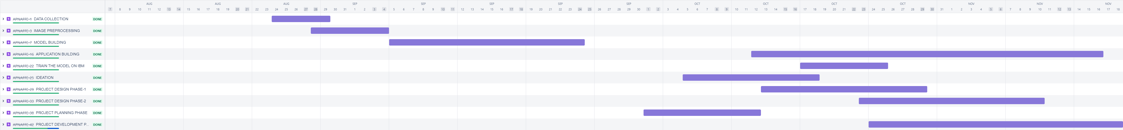

***MONTHLY PROGRESS REPORT:***

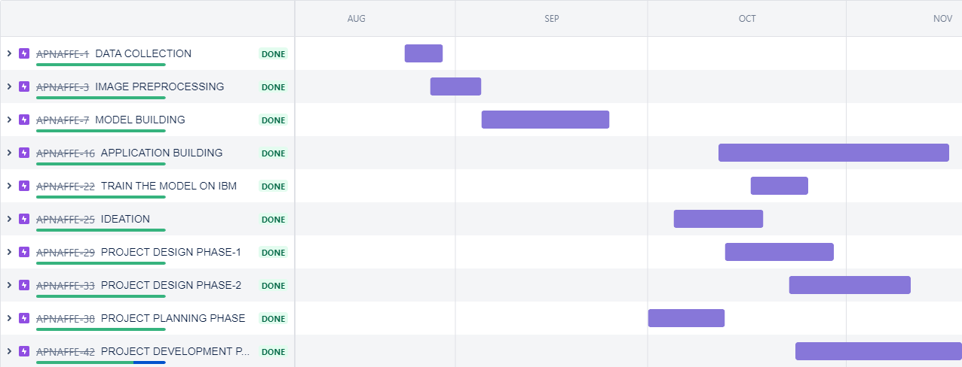

***QUARTERLY PROGRESS REPORT:***

